CONSENT FORM

Location: Date:

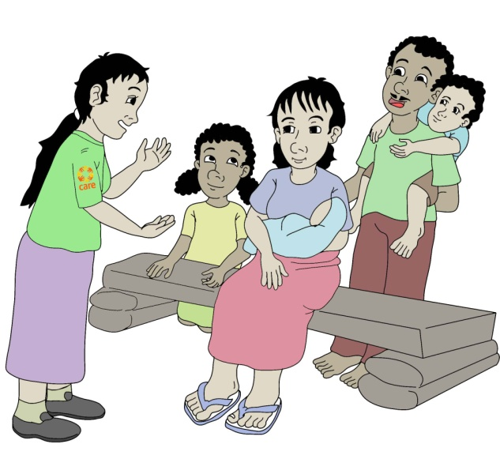
I (name)…………………, ………… years old give CARE Australia and CARE International, the right and permission to use information about me and my family (if relevant). This could include names, ages, statements, images, video and any voice recordings.
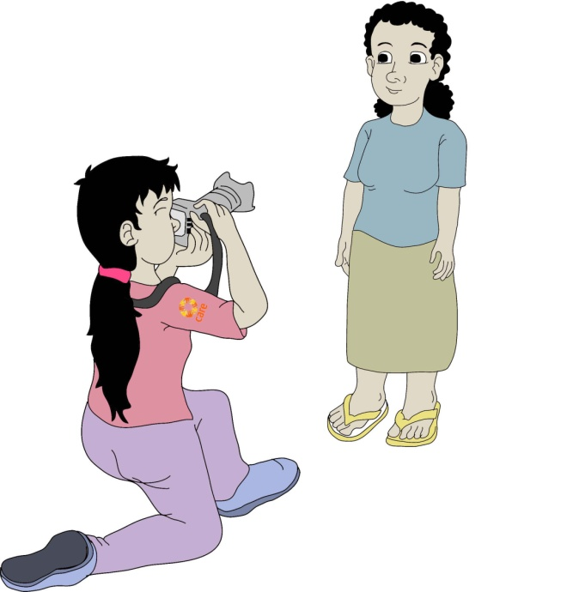
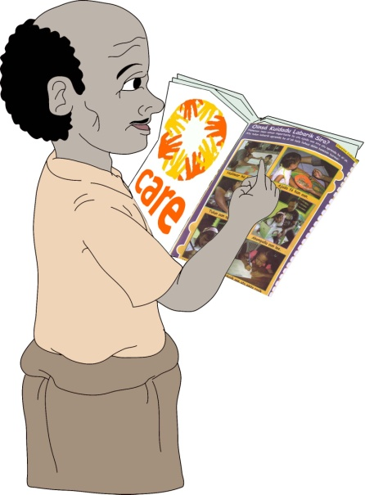
I am happy for CARE to interview me and my family.
I am happy for CARE to take photos or video of me and my family
I am happy for people to read or hear about my / our story
I am happy for CARE and its corporate partners to use my story to tell others about my life experiences, to promote CARE’s mission around the world
I have read, or have been read, this Consent before signing it, and I understand this Consent.
Signature: …………………………………..
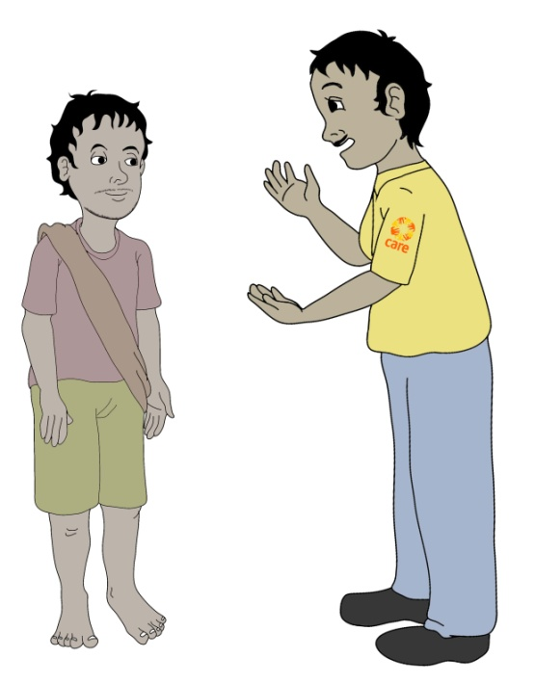

Family members (over 18) for specific quotations or photos

Name:

Age:

Signature:

Name:

Age:

Signature:

Name:

Age:

Signature:

Name:

Age:

Signature:

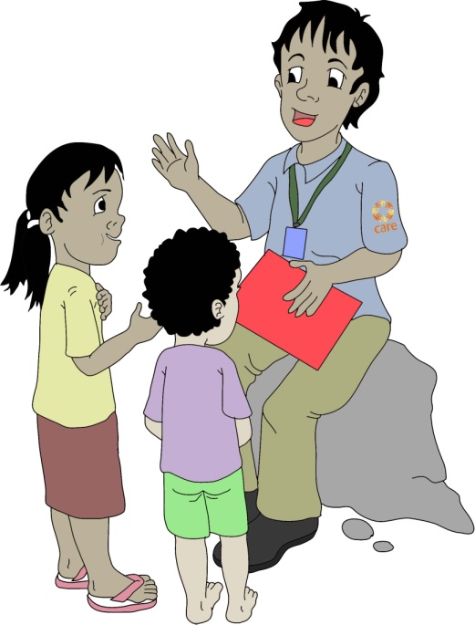

Family members (under 18) for specific quotations or photos

I certify that I am the child’s parent or legal guardian and give my consent on behalf of the child

Name:

Signature:

Child’s name:

Age:

I certify that I am the child’s parent or legal guardian and give my consent on behalf of the child

Name:

Signature:

Child’s name:

Age:

I certify that I am the child’s parent or legal guardian and give my consent on behalf of the child

Name:

Signature:

Child’s name:

Age:

