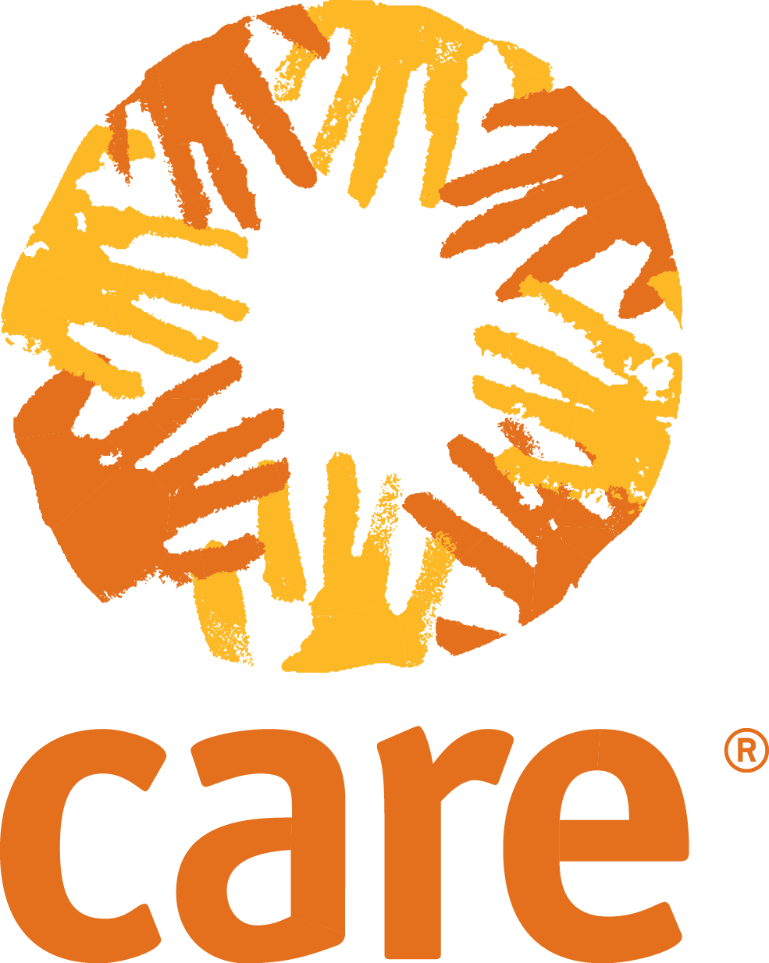

Sector Specific Questions
These questions are not required, but are suggestions that will allow you to gather additional information that may be useful for your Rapid Gender Analysis. Select questions/sections that are relevant to your specific context and situation.

Shelter
- What was the process for building and maintaining shelter before the crisis?
- Who may need targeted and affirmative actions to support them in shelter construction? (e.g. frail and housebound older men and women, persons with disability)
- What are the community practices and cultural patterns for household and care arrangements?
- What are the cultural and community practices concerning shelter/houses/spaces and access to them? Are any specific shelters required for religious practices?
- What are the land and property ownership laws and practices?

Non-food items
- What are the different Non-Food Item (NFI) needs of women and men, by age and ethnic background? (Compare to what they had before the emergency)
- How did destitute women, households headed by women, and other vulnerable groups get NFIs before the emergency?
- Do men have cash for NFIs? Do women have cash for NFIs?
- How does the community collect firewood/what are the fuel sources? What types of cooking stoves do they use?
- What are the sleeping and bedding arrangements, including use of mattresses and blankets? What are the additional bedding requirements for elderly, and for persons with disabilities?
- What clothes do women and men normally wear? Are there any daily clothing needs not being met for any vulnerable groups? What are the specific clothing needs for pregnant and breastfeeding women?

Water, Sanitation and Hygiene
- What are the community’s water, sanitation and hygiene practices? How do they vary for women, men, boys and girls?
- What uses of water are women, men, girls and boys responsible for (e.g. collection, cooking, sanitation, gardens, livestock)?
- How do family members share water with each other (quantity and quality)?
- Who has access to and control of water and sanitation resources? Who is responsible for water-use decisions and management?
- What cultural practices affect women’s hygiene and sanitary needs, especially during menstruation? (e.g. Considerations around belief of impurity implies that access to certain spaces is limited/restricted.)
- Are water points and sanitation facilities safe for everyone to use (especially women, children and other vulnerable groups like older people and persons with disability)?
- Are water points, toilets and bathing facilities located and designed for privacy and security? Are water points and sanitation facilities easily accessible and secure for vulnerable groups who have mobility problems as well as communication problems?

Health
- How has the health of the population changed since the crisis? Are women and men affected differently by diseases or other health problems? If so, what is the breakdown by sex and age?
- What is the breakdown by sex and age of the crude mortality rate? Is there a disproportionate number of deaths among women, men, girls or boys? If so, why?
- Who provides health care to whom? For example, do local beliefs and practices let male health workers care for women? Are the healthcare service points accessible to frail and housebound vulnerable groups?
- What are the local beliefs and practices on pregnancy and birth, disposal of dead bodies, washing, water use, cooking and animal care? Are any of these harmful for women, men, girls or boys?
- Do women and men talk about and/or get information about health differently? What cultural and religious practices affect health care?
- Do vulnerable groups like older people and persons with disability use mobility aids and assistive devices like walking sticks, wheelchairs, spectacles, hearing aids, or dentures? Do they have access to essential medicines?

Food Security: refer to the SEAGA for more details of how to assess gender and food security
- Can all members of the community/household get and prepare food? Does food insecurity differ by age and gender?
- Who gets food aid on behalf of the household? Who decides how to use it? (How is food shared within households? Who eats first?)
- Are single-headed, child-headed and vulnerable group-headed households getting enough food? Do they require special assistance for receiving food?
- Are there any food taboos or restrictions for women, men, children under five or pregnant and breastfeeding women?
- What are the eating habits of the population as a whole? Do food needs differ by age and gender?
- What are the cultural or religious food preferences of women and men in the community?

Livelihoods: refer to the CLARA for more details of how to conduct a gender and livelihoods assessment
- What main livelihood assets (land, seed, livestock, equipment, access to markets) does the community need? How has the emergency affected these?
- What livelihood assets do women and men control? Has the emergency affected who controls what?
- What types of agriculture, farming, fishing, trade and food supply existed before the emergency? What role did women and men play in these sectors? What about disabled women and men?
- What local practices affect ownership and distribution of agricultural land? What are women’s property and inheritance rights?
- What skills do women have? What skills do men have? What training needs are there for each group?
- Do local customs forbid women or men from doing any tasks?
- How much time do women, men, girls and boys spend on unpaid work (fetching water, cooking, collecting firewood, caring for children, washing clothes, etc.)?

Nutrition
- How does nutritional status (z-score weight-for-height and MUAC score) break down by sex and age? Are any groups (girls or boys, older men or women) disproportionately affected, and if so, for what reason?
- What is the nutritional status of women of childbearing age? What are the levels of anemia?
- How are gender and social position connected to malnutrition?
- What are the special nutritional needs of pregnant and breastfeeding women, people with HIV/AIDS and other vulnerable groups?
- Are there any beliefs or practices that may affect the nutritional status of women, men, girls and boys differently?
- Are a lot of women having trouble breastfeeding? Are female and male babies breastfed differently?
- How are children fed when they are at school? It is possible children with disabilities are not in school, if so, what is their nutritional status?

Early Recovery
- Who is able to take part in debris removal and waste management? Do they have access to safe equipment and guidance?
- As community roads and essential infrastructures are restored, who will be the main users of these services? Whose needs do they cater to?
- In rapid structural assessment of public buildings, who chooses which buildings are assessed first, who uses them? Which basic equipment and service deliveries are restored first, whose needs they cater to?
- Who is recruited to cash-for-work activities? Are there enough opportunities for both women/ men?

Education
- How has the emergency affected girls’ and boys’ access to education?
- How many adolescent girls and boys are out of school?
- What safety and access problems do schools have?
- Do girls and boys have equal access to school locations? Do they have equal access to all levels of schooling? Do girls and boys with disabilities access mainstream or special schools?
- Are any girls and boys stigmatised by their war experiences (e.g. being raped or a child soldier)? Does this stop them going to school?
- What are the direct and indirect costs for girls and boys to attend school?
- Do parents think the school is close enough for girls to get to? For boys? Is the way safe for girls and boys?
- Are the school’s toilets accessible and safe? Are there enough? Do girls and boys have separate toilets? Is water available?
- Does the school have male and female teachers? At all grade levels? What are their qualifications and experience?
- Do school staff know how to report and follow up harassment and Sexual Gender Based Violence (SGBV)? Do they have suitable materials and services to help boys and girls recover from SGBV?

Protection: refer to the GBV Responders for more details of how to conduct a gender-based violence assessment
- What are the specific protection needs of women, men, boys, and girls and individuals with disabilities? What is the breakdown by age and sex? What are the continued risks for each group?
- What factors increase tensions, and how do they affect women, men, boys and girls? How does the spread of weapons affect women, men, boys and girls?
- How do human rights and humanitarian law violations affect women, men, boys, and girls differently?
- Can people safely report and seek redress for violations of humanitarian law? (This includes Sexual Exploitation and Abuse)
- What are the community’s laws and customs on abductions, trafficking of humans, sex work, slave-like practices, SGBV, early/forced marriages, elder abuse and property rights? How do these affect women, men, boys and girls and individuals with disabilities?

Socio-economic and Gender Analysis (SEAGA)is a toolkit developed by FAO
Cohort Livelihoods And Risk Analysis (CLARA) a gender and age assessment tool developed by Oxfam and Women’s Refugee Committee.
Mid-Upper-Arm-Circumference.
GBV specific assessment tools developed by International Rescue Committee

